**Windows Command Line**

**This article is for the Windows user! We will offer more detail about how to apply the knowledge from the Command Line course in the Windows environment.**

**How do Windows users access the command line?**

We will discuss a few options for accessing the command line in Windows. We’ll introduce Windows Command Prompt, which is the system default for basic tasks, and Powershell, which is a more advanced tool often used by system administrators. We will also touch on Git Bash, which will allow you to use all the commands we teach in this course on your Windows system.

At the end of the article, we will also provide Windows Command Prompt equivalents of the Bash commands from this course.

**Windows Command Prompt**

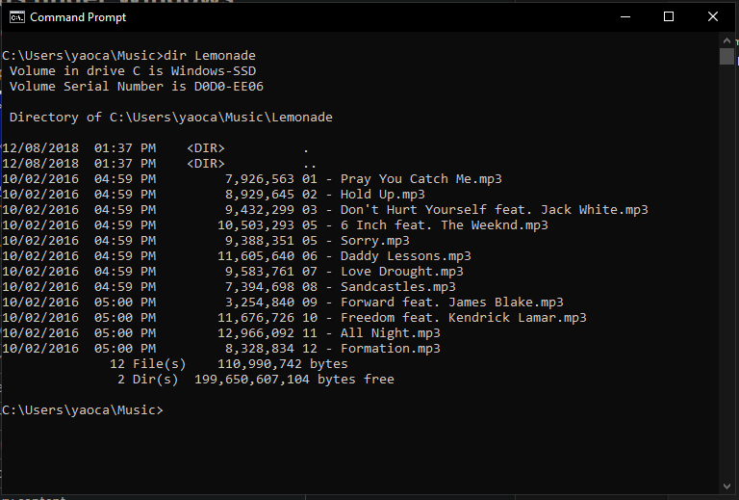

Windows Command Prompt comes preloaded into Windows systems. This tool allows for basic system-related tasks. For example, you can run the following command to shut down the computer in two hours:

shutdown -s -t 7200

This command prompt is quite limited in its functionality especially when used for software development, but has been kept to maintain backwards compatibility. You can access this tool by bringing up the Start menu and typing **cmd**. We’ll share some equivalent commands to Mac/Linux Bash at the end of the article!

**Powershell**

[Powershell](https://docs.microsoft.com/en-us/powershell/?view=powershell-7.1) is an important tool for system administrators in Windows environments. It was introduced in 2006 to allow users to write much [more powerful scripts](https://docs.microsoft.com/en-us/powershell/scripting/samples/sample-scripts-for-administration?view=powershell-7.1), and to redirect outputs of commands like one can in Bash.

PowerShell has its own syntax where commands are literal verbs of what’s happening. For example, the following command changes the current directory to **C:\Desktop**.

Set-Location "C:\Desktop"

**Windows Terminal**

As of summer 2020, Windows has released [Windows Terminal](https://www.microsoft.com/en-us/p/windows-terminal/9n0dx20hk701), an interface that combines Command Prompt, Powershell, and, if it detects that you have Windows Subsystem for Linux installed, Linux Bash!

**Git Bash**

Git Bash lets you use Bash commands on your Windows computer. It is our most recommended Windows command line setup for users that need the command line primarily for software development. Many software tools include Bash commands to install, configure, and run them.

Below is a tutorial for setting Git Bash up on Windows:

**Bash to Windows Command Prompt Translation Guide**

Here’s a quick table of Bash commands and their Windows Command Prompt equivalents if you want to try them out on Windows!

**Navigation**

| **Action** | **Mac/Linux Command** | **Windows Command** |
| --- | --- | --- |
| List files/directories | **ls** | **dir** |
| Print working directory | **pwd** | **chdir** |
| Change directory | **cd** | **cd** |
| Create new directory | **mkdir** | **md** |
| Create new file | **touch** | **echo "hello world" > hello.txt** |
| Clear screen | **clear** | **cls** |

**Manipulation**

| **Action** | **Mac/Linux Command** | **Windows Command** |
| --- | --- | --- |
| View contents of an individual file | **cat** | **type** |
| Copy file or directory | **cp** | **copy** |
| Move files (without making copy) | **mv** | **ren** |
| Delete files or directories | **rm** | **del** |

**Redirection**

| **Action** | **Mac/Linux Command** | **Windows Command** |
| --- | --- | --- |
| Redirect output | **>** | **>** |
| Pipe, or transfer, output | **|** | **|** |
| Append output to another file | **>>** | **>>** |
| Search files for a pattern match | **grep** | **find** |

**Environment**

In Windows, there are two types of environment variables: System Variables and User Variables. Each variable is in the form of a name and a value.

You can view and edit the variables through a GUI by opening the Start menu and search “Edit environment variables” to open up the following window:

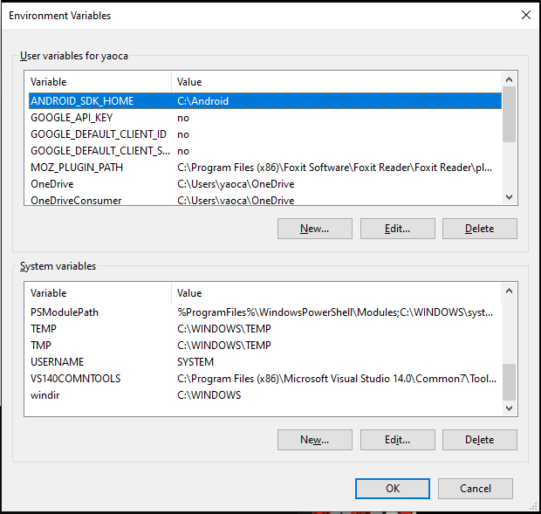  
To read the environment variables in the command line, these are the Windows commands compared to the Mac/Linux Bash command.

| **Action** | **Mac/Linux Command** | **Windows Command** |
| --- | --- | --- |
| View all environment variables | **env** | **set** |
| Set an environment variable | **export VAR=value** | **setx variable value** (administrator mode) |
| Print specific variable | **echo $VAR** | **echo %VAR%** |

**Additional Resources**

We’ve covered the basics of Windows Command Prompt, but if you’re looking for more, here are some good resources:

* [Windows commands cheatsheet](https://cmdref.net/os/windows/command/index.html#windows_commands_cheat_sheet)
* [Microsoft’s documentation](https://docs.microsoft.com/en-us/windows-server/administration/windows-commands/windows-commands)